Stricktux-Addon: Debian-Swirl
You can add a Debian-Swirl to Tux's belly.
Materials:
- Yarn in the same weight as the body
- colors: white and red



Swirl white and red
The swirl can be knitted directly in stranded knitting, or can be applied afterwards in duplicate stitch.
There is a good duplicate stitch tutorial available at
http://bellaknitting.typepad.com/bella_knitting/2007/08/duplicate-stitc.html

The chart starts at row 3 of Tux's belly.

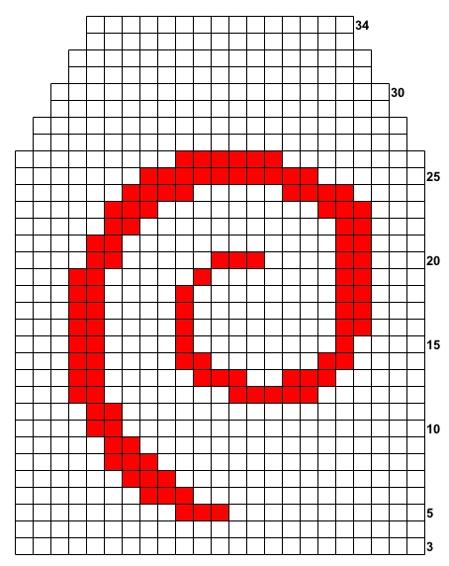

Do you like this pattern?
This pattern is provided, as are all the patterns on stricktux.de, free of charge.
The Creative Commons license allows you to redistribute and change this pattern, but not to sell it. The only conditions are that my name must be included on any altered patterns as author of the original pattern, and that you also distribute under the CC:BY-NC-SA license.
Nonetheless, I would be pleased by some small recognition for the pattern. I would be particularly glad to see pictures of projects from stricktux.de patterns. Please send your pictures to bilder@stricktux.de.
Mention stricktux.de on your social media accounts or your blog or wherever else you can think of. Every visit to the site tells me I'm not just doing this for myself!

Birgit Hücking

